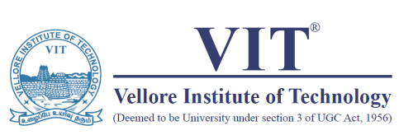

OFFICE OF STUDENTS’ WELFARE

Event Report 2019

|  |  |  |  |
| --- | --- | --- | --- |
| Club-Chapter Name | IEEE SPS | | |
| Event Name | Introduction to Digital circuits through Verilog | Date | 01/02/2019 |
| Venue | TT - 205 | No. of Participants | 30 |
| Event Description |  | | |
| The Students were introduced to the concepts of Digital electronics by bringing an analogy with its counterpart. i.e Analog circuits, they were also introduced to gate level modelling and data level modelling.  Basic usage of digital circuits based appliances in our day-to-day lives was used as reference and modelling was done on Model simulator.  At the end,  The Students were also encouraged to model their own sets of circuits and implement the design through gate level modelling on the simulator  The event came to a fruitful end by giving them the introduction about the sequential circuits and storage devices in Digital electronics | | | |
| Collaborating Agency/Club/Chapter/Others: None | | | |
| Photo | | | |
|  | |  | |
|  |  |  |  |
| Student Coordinator | Faculty Coordinator | Asst. Director SW | Director SW |
| Name: Prakhar | Name: Vaegae Naveen Kumar |  |  |
| Reg. No. 16BIS0017 | Emp. ID: 13737 |  |  |